
Certificate in Animal Management (CAM)
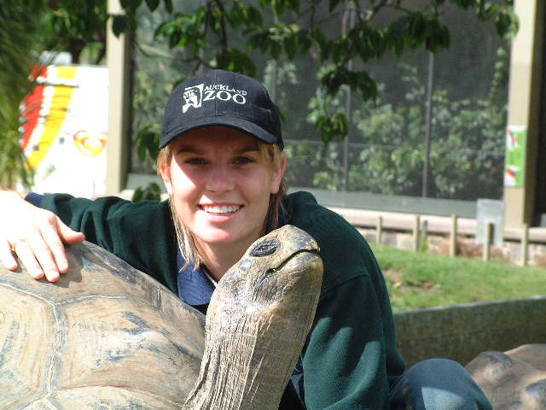
Captive Wild Animals

Things You Need to Know Before Applying

IMPORTANT DEVELOPMENT FOR 2017
The Certificate in Animal Management and its endorsements (including Captive Wild Animals) are undergoing a mandatory re-development in order to deliver the new NZQA qualifications. It is envisaged that the new New Zealand Certificate in Animal Management qualification will be delivered in 2017, however, the entry requirements (as set by NZQA) have changed from those advertised on the Unitec website. Please see the box below to ensure you meet these higher requirements.

New Admission Requirements for 2017 admission (these supersede those on the Unitec website):
For those people entering this qualification direct from school the following entry requirements apply:
- have completed 36 NCEA credits at level 2
- have a minimum of 12 NCEA credits in English at Level 2 and 12 credits of a relevant science at level 1
Or
- The New Zealand Certificate in Animal Care (Level 3)

Entry requirements for adult students:
- evidence of ability to study at a tertiary level and
- evidence of the equivalent NCEA credits as apply to school leavers, listed above.

A distance-learning programme requires students to be self-motivated and committed, and to have excellent time-management skills. The time required to attend block courses, exams, practical assessments, work experience and to adequately cover self-directed study (research, reading, revision) and assignment writing, is equivalent to a full-time on-campus programme (1200 hours) even though it is distance-learning. If studying full-time, students are eligible for student loans and allowances, however, cross crediting of more than one course within the programme may change your eligibility for student allowance. Contact Studylink (www.studylink.govt.nz/) to check for eligibility.
Prospective students MUST have consistent, easy access to a computer with broadband and with appropriate word processing and slide presentation software (MS Word 97-2003 or above, and MS Powerpoint 97-2003 or above) and be proficient at word processing, web browsing and e-mail communication.
Entry is open to anyone of 16 years old as at February 1st in the year of study. However, you must also meet the academic entry requirements (as above) and gain a wrok experience placement at an approved zoo. Please note; zoos have differing minimum age requirements for their work experience placements and these may be greater than the minimum of 16 years as required by Unitec. Please check that you meet the minimum age requirements for you chosen zoo.

Block Teaching Courses
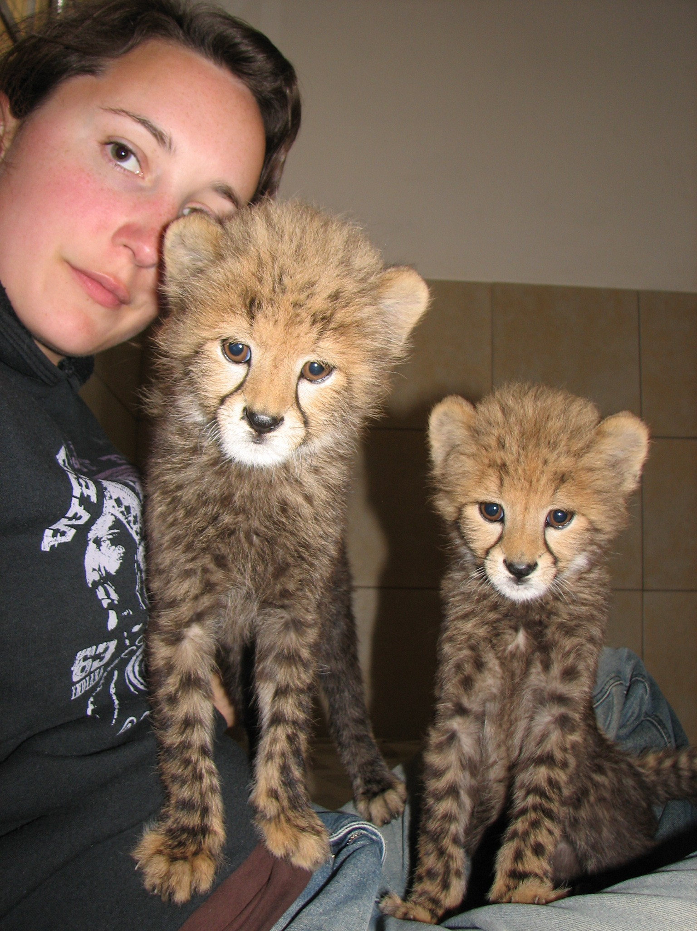
As a student, you will be required to attend 3 block teaching courses per year held at Unitec (Auckland). These have run in the past in mid to late February, mid-June and late September*. The first two are of 6 days and the third is 5 days in duration. The block courses are intensive in nature and provide lectures, debates, handling practice, applied practical skills, and formative and summative practical assessment. It is essential that you attend all days in all block courses within your year of study (unless cross crediting particular courses).
Block courses start early on the first day and as such it is advised that if travelling some distance from outside Auckland, you arrive the day before the start of the block course to account for any travel delays (late flights, traffic congestion etc). Each block course ends at 5.45pm latest on the last day.
Tea/coffee is provided for you throughout each block course, however, no food is provided. Food outlets may be found on campus although block course 1 occurs outside usual on-campus semester time and thus food may be limited.
Accommodation is also NOT provided. There is limited on-campus student accommodation available (http://www.unitec.ac.nz/?1D04B316-145E-6A3C-6ECF-576819688778) that needs to be booked in advance through the accommodation manager (accommodation@unitec.ac.nz). Otherwise there is plenty of accommodation available within the West Auckland area.
*these dates may vary from year to year

Programme Courses
The programme currently consists of seven compulsory courses (you may know them as papers) as in Table 1 below, all of which you must pass in order to receive the Certificate. However, the name and weighting of these courses may change when re-developed for 2017

Level | Course No. | Course Name | Credits | Pre-requisites | Co-requisites
Level 4
4 | NSCI 4700 | Vertebrate Anatomy and Physiology | 15 | NIL | NIL
4 | NSCI 4730 | Captive Wild Animal Practicum | 30 | NIL | NIL
4 | NSCI 4731 | The Captive Wild Animal Industry | 15 | NIL | NIL
4 | NSCI 4704 | Conservation and Animal Management | 15 | NIL | NIL
4 | NSCI 4732 | Captive Wild Animal Behaviour, Training and Enrichment | 15 | NIL | NIL
Level 5
5 | NSCI 4733 | Contemporary Issues in Animal management | 15 | NIL | NIL
5 | NSCI 5741 | Principles of Captive Wild Animal Husbandry | 15 | NIL | NIL
Table 1: Courses for CAM Captive Wild Animals – all courses are compulsory. Please note – these courses may change for 2017, although the content across all courses will be very similar.

The courses contain a range of subject matter covering the following:

In-situ and Ex-situ Conservation | Records and Recording Systems
Practical Zoo keeping Skills | The Zoo Industry and Associated Organisations
Communication skills | General Animal Health and Hygiene
Animal Behaviour and Welfare | Tertiary Study Skills
Breeding and Nutrition | Housing, Enclosures and their Maintenance
Animal Law and Ethics | Emergency Procedures
Enrichment and Conditioning | Vertebrate Anatomy and Physiology

Work Experience
The programme requires that you obtain a total of 280 hours structured work experience at an approved facility in the year of study, or within the first year of study if taken over two years (only available to full-time zoo keeping staff with support from employer). The 280 hours are further split into 3 minimum requirements on certain animal groups (see table 2).

Animal Group | Invertebrates, Fish, Amphibians or Reptiles | Birds | Mammals* | Total required for course
Minimum hours work experience per animal group | 40 | 40 | 80 | 280
Table 2: Work Experience Requirements for Certificate in Captive Wild Animals

*NB Work experience with mammals must include a minimum of 16 hours with at least one highly dangerous animal species – i.e. where keepers would under no circumstances enter the enclosure with the unrestrained animal.
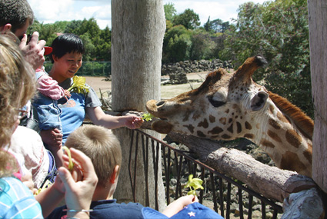

The approved facility has an obligation with Unitec to instruct you in the practical skills of zoo keeping during your work experience up to a maximum of 280 hours. The facility in which you gain your work experience will depend largely on where you live or where you are based during your study period. Facilities that have an MoU with Unitec at present are listed in Table 3 along with contacts. If you wish to gain work experience at any other facility not listed below, you must contact the Curriculum Leader at Unitec first, to discuss options and suitability. Each zoo will have different cut-off dates for work experience applications (some as early as July) and as stated earlier may require applicants to be older than 16 years in order to be allowed on site. There are around 40 placements given across New Zealand each year and gaining a placement is highly competitive. Please contact zoos as soon as possible to express interest.

Table 3
Regions | Name | Contacts
Auckland Zoo, Auckland | See last page | See last page of this pamphlet
Wellington Zoo, Wellington | David French  or  Harmony Wallace | Telephone: DDI: +64 4 381 6755  Email: David.French@wellingtonzoo.com  Or Harmony.Wallace@wellingtonzoo.com
Orana Park, Christchurch | Lucie Boehmler | Telephone: 03 359 7109 x 810  Email adf@oranawildlifepark.co.nz
**Willowbank, Christchurch | Shaun Horan | Telephone: 64 3 359 6226  Email: Shaun@willowbank.co.nz
Hamilton Zoo, Hamilton | Morel Rand | Telephone: 64 07 838 6961  Postal Address  Email: morele.rand@hcc.govt.nz
**National Aquarium, Napier | Rob Yarroll | Telephone: 06 834 1404  Email: rob@nationalaquarium.co.nz
**Brooklands Zoo,  New Plymouth | Eve Cozzi | Telephone: 06 759 6060  Email: enquiries@npdc.govt.nz
**Natureland, Nelson | Meg Selby | Ph: 03 548 6166  Email: meg@natureland.nz
**Butterfly Creek, Auckland | Paul Barrett | Ph: 09 275 8880 ext 218  Email: paul@butterflycreek.co.nz
** These facilities cannot provide for the full scope of animal experience required as per Table 2 and therefore applicants must contact other approved facilities to gain experience in areas that cannot be accommodated by these smaller facilities.
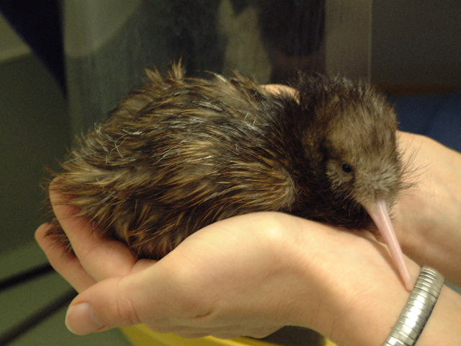

IMPORTANT:
Until the 280 hours work experience has been authorised in writing by the facility/facilities concerned, you cannot be accepted into this programme at Unitec.

If you live in Auckland and are wishing to obtain work experience at Auckland Zoo, please read the information at the end of this document carefully. If you are wishing to obtain a work experience position for this programme in any other zoo, you will need to contact them directly.
IMPORTANT: Regardless of where you apply for work experience, it is essential that you send in a completed Unitec enrolment form clearly stating which zoo facility/facilities you are applying to for work experience.

Costs
Approximately $6317* (not including required reading, travel and accommodation costs to and from block courses and work experience expenses). If studying full-time, students are eligible for student loans and allowance.
© Christian Walzer, International Takhi Group
*(Fees have not been set for 2016. This cost is an indication only.)

If you have any queries regarding this programme, please call Student Central:

0800 10 95 10 or +64 9 815 2945
email study@unitec.ac.nz

Good luck.
Lorne

 | Dr Lorne Roberts  Programme Leader and Senior Lecturer | Environmental and Animal Sciences  Email lroberts2@unitec.ac.nz Tel +64 9 815 4321 Extn 7088

The following is for your interest only at this stage – they are not required reading.

RECOMMENDED READING:
Highly recommended
- Zookeeping: An Introduction to the Science and Technology (Irwin, Stoner & Cobaugh) University of Chicago Press
- Zoo Biology and Management (Rees, P.A.) Wiley-Blackwell
- Zoo Animals: Behaviour, Management and Welfare (Hosey, Melfi & Pankhurst) Oxford Uni Press
Recommended
- The Welfare Ark (Margodt K.) University Press
- The Zoo Story (de Courcy C.) Penguin Books
- Second Nature (Shepherdson D.J.) Smithsonian Institute
- Ethics on the Ark (Norton B.J. et al) Smithsonian Institute
- Wild Mammals in Captivity (Kleiman D.G. et al) University of Chicago Press
- Last Animals at the Zoo (Tudge C.) Island Press
- Zoo Culture (Mullen B. and Marvin G.) University of Illinois Press
- Environmental Enrichment for Captive Animals (Young, R.) Blackwell Science Ltd
- After the Ark (Mazur N.) Melbourne University Press
- Modern Ark, The - Story of Zoos Past, Present and Future (Croake V.) Avon Books Inc.
- Different Nature, A (Hancocks D.) University of California Press
- Measuring Behaviour - An Introductory Guide. 2n Ed (Martin P. and Bateson P.) Cambridge University Press
- Zoo - A history of zoological gardens in the west (Baratay E. and Hardouin-Fugier E.) Reaktion Books Ltd
- Zoo Man (Maple T. and Archibald E.) Longstreet Press
- New Worlds, New Animals: From Menagerie to Zoological Park in the 19th Century (Hoage and Deiss)
- Building a Future for Wildlife – The World Zoo and Aquarium Conservation Strategy (Olney, P.J.S.) WAZA Executive Office
- Websites: ARAZPA (now ZAA); WAZA; IUCN; CITES; DoC (NZ); MAF and all zoo websites (with particular reference to New Zealand and Australian Zoos)

Auckland Zoo Work Experience ONLY:

Auckland Zoo accepts a maximum of 14 students per year for the structured work experience relating to the Certificate in Animal Management (Captive Wild Animals) and applicants must be a minimum of 18 years old. Work experience is held on either a Monday or Tuesday 8.00am-4.30pm minimum, every week from late February through to November. To be fair to all, successful applicants cannot choose their work experience day.
Competition is very high for these positions. To enable us to choose the correct students, you will be required to attach an up to date CV and a letter of no more than 300 words to your application at Unitec (just as you would also attach your school results and proof of residence) with the following information:

- What you hope to gain from the certificate and why;
- What your involvement has been with animals (or the environment) in the past. This does not have to be work oriented. It may include pets, volunteer work, previous study, association with other organisations etc;
- Why you believe that zoos are necessary in today’s society (with particular reference to New Zealand).

There is a cut-off date for applications to Auckland Zoo of 1st October in order that zoo and Unitec staff may evaluate your application; interviews are timetabled for late October/early November. If you are successful in obtaining a work experience position, and fulfil Unitec’s minimum requirements for the programme, you will automatically be accepted into the CAM (CWA) programme by Unitec Institute of Technology.

Please note - all Auckland Zoo work experience students must attend an induction course usually scheduled within the week prior to the first Unitec block course in early February. This is a requirement of Auckland Zoo only and is for the benefit and safety of all students, staff, public and animals.

